Dublin Technological University,
Certificate, Cloud Solutions Architecture (2020)

Implementation Iteration 1.2

Student Name: Alan Duffin
Student ID: X00159409

Submission Material

Source Code NodeJS / Lambda | https://github.com/GeneralYeager/tallaght.mortgages/tree/master/tud.mortgages/Tallaght-Mortgages-App
Workflow Cloudformation | https://github.com/GeneralYeager/tallaght.mortgages/blob/master/mortgage.workflow/StateMachineV1.json
DynamoDB Cloudformation | https://github.com/GeneralYeager/tallaght.mortgages/blob/master/mortgage.dynamo/dynamo-create.yml
SNS Cloudformation | https://github.com/GeneralYeager/tallaght.mortgages/blob/master/mortgage.dynamo/sns-topics.yml
Lambda / API Gateway Cloudformation | https://github.com/GeneralYeager/tallaght.mortgages/blob/master/tud.mortgages/Tallaght-Mortgages-App/template.yaml
Table A.

Iteration 1.2 Tasks

Building upon last weeks progress report, this document outlines the additional project tasks that have been completed for implementation phase 1. The follow tasks were completed this week.
Project Phase | Service / Area | Implementation Task
Build / Development | AWS SNS | Build SNS Topics and Subscriptions.
Test |  | Test Notification Events and Subscriptions
Build / Development | AWS Lambda | Build Rest API to start Step Function execution.
Build / Development | AWS Step Functions | Build CloudFormation template for very basic initial Workflow.
Design | AWS Step Functions | Design solution for human interaction / decision making.
Test | AWS Step Functions | Test State Transitions / Events
Table B.

I have built out a suite of Lambda services that will allow a basic workflow state machine. Users can create customers and mortgage applications. Mortgage applications can be updated and have their workflow status modified. Most of these functions are accessible as HTTP services via API Gateway. Some Lambda functions are developed specifically for use by the Step Function state machine.
The users can initiate the long running mortgage approval process via a HTTP Rest API published via API Gateway. State changes of the mortgage application or future decision points that require human interaction can initiate SNS notifications to either the Broker that inputted the case or Underwriters that must approve the case.

Plan for Iteration 2.1

Project Phase | Service / Area | Implementation Task
Build / Development | AWS Lambda | Build Rest API to allow human decisions.
Build / Development | AWS Step Functions | Extend / Enhance CloudFormation template for Phase 2 Workflow.
Build / Development | AWS Step Functions | Design solution for human interaction / decision making.
Build / Development | DynamoDB | Implement new DB schema to map mortgage application to Step Function execution id. This is required to allow users approve or reject applications without reference to the step function execution id.
Test | AWS Step Functions | Test State Transitions / Events / Human interaction
Table C.
The plan for the next project iteration is to fully implement the mortgage approval workflow as seen in Figure AWS.STEP.1
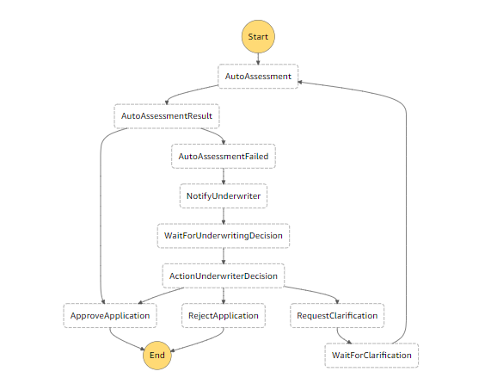
Figure AWS.STEP.1

Servlerless / Lambda Functions

The following Lambda function have been implemented for Phase 1 of this project. Figure AWS.LAMBDA.1

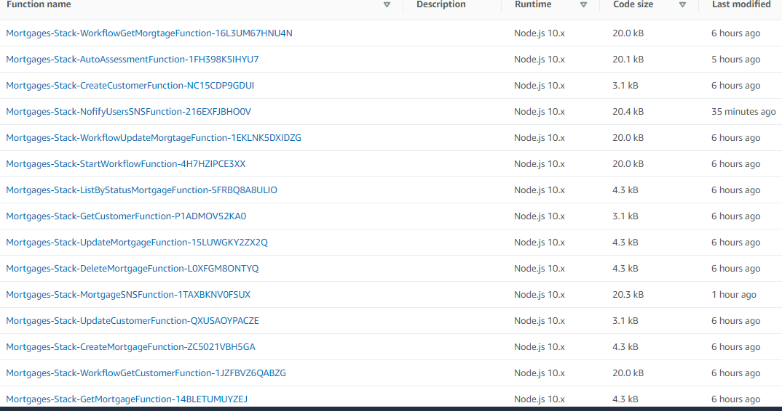
Figure AWS.LAMBDA.1

The source code and deployment template for these functions are available at the GitHub repository listed in Table A or in the Appendix.
It has been necessary to perform a significant restructuring of the code base due to the fact that it is not possible to invoke HTTP endpoints from AWS Step Functions. This was only discovered recently. This required me to refactor many of the Lambda functions to extract the Dynamo DB CRUD actions into separate NodeJS modules that can be called from Lambda functions written to support API Gateway resouces and from Lambda functions written to support Step Function tasks.

API Gateway Paths

The following API Gateway paths have been created. Figure AWS.API.1

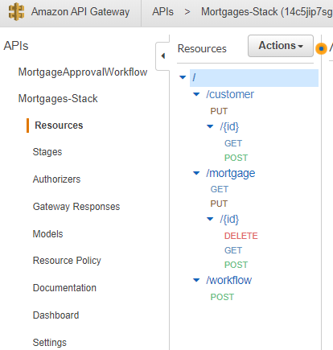
Figure AWS.API.1

The purpose of each of these API Paths is listed below. Figure AWS.API.2
Service | URI | ACTION
Create Customer | /customer/ | PUT
Get Customer | /customer/{id} | GET
Update Customer | /customer/{id} | POST
Create Mortgage | /mortgage/ | PUT
Get Mortgage | /mortgage/{id} | GET
List Mortgages by State | /mortgage/status={statusText} | GET
Update Mortgage | /mortgage/{id} | POST
Delete Mortgage | /mortgage/{morgageId}/ | DELETE
Start Approval Workflow | /workflow/mortgageId={mortgageId} | POST
Figure AWS.API.2

Development – Workflow Implmentation – Step Function.

The first iteration of the Step Function State Machine is shown in Figure AWS.STEP.1

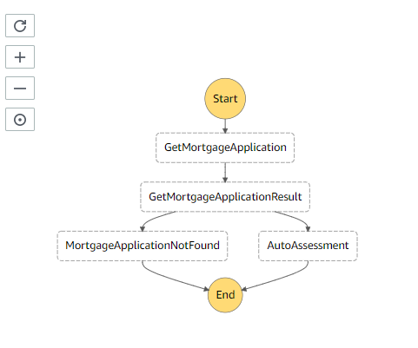
Figure AWS.STEP.1

The workflow contains the following steps:
1 Obtain the mortgageId from the HTTP POST / API Gateway. Call the GetMortgageApplication Lambda to load the actual mortgage data from DynamoDB.
2 Evaluate the result. If a valid mortgage application is found, then initiate the AutoAssessment function.
3 If there is no valid mortgage application that matches the mortgageId then initiate the MortgageApplicationNotFound task with invokes the NofifyUsersSNSFunction Lambda function. This function creates an SNS notification to the Broker Topic to inform them that the Approval Workflow did not complete successfully.

The next iteration of the Workflow will allow for Human interation / decision making, further enhancements such as Underwriting clarification requests, SNS notifications for Mortgage status changes e.g. 'With Underwriter', 'Approved', 'Declined'. Human interaction will require that the Step Function execution is paused and that a restart token is issued to the the user that must make the decision. However it is not practical for a users to save a computer generated token. So this token will be saved to DynamoDB along with the mortgageId to allow automation of the decision process.

We can see from the following screenshots the various scenarios that are dealt with by the workflow.

When we start a Workflow execution with a mortgageId that does not exist then we are delivered an email to the BrokerSNSTopic stating that fact. The workflow process is long running, therefore the Step Function startExecution function is asynchronous. It returns before the workflow completes, so the only information that will be returned by the HTTP request that initiates the workflow is the workflow execution Id. If we wish to see the final output of the Workflow that is available (see below) in the output section of the workflow execution instance.

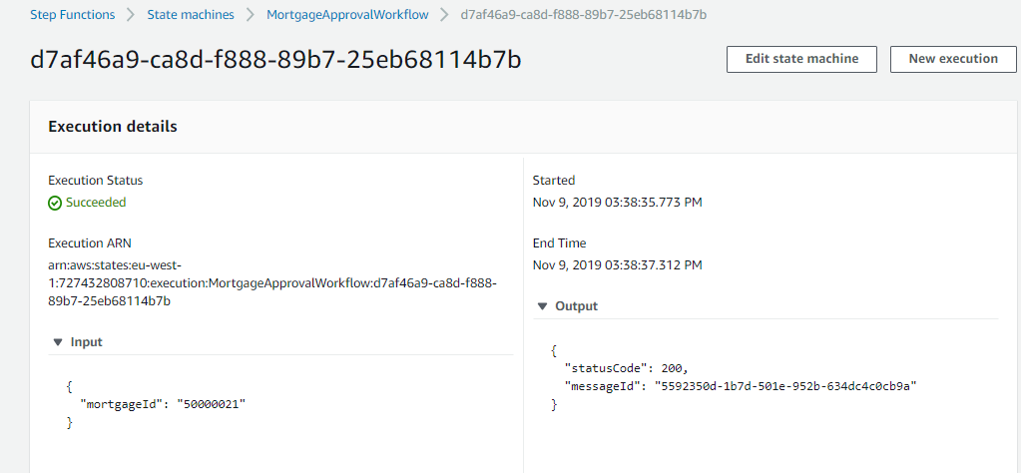
Figure AWS.STEP.TEST.1

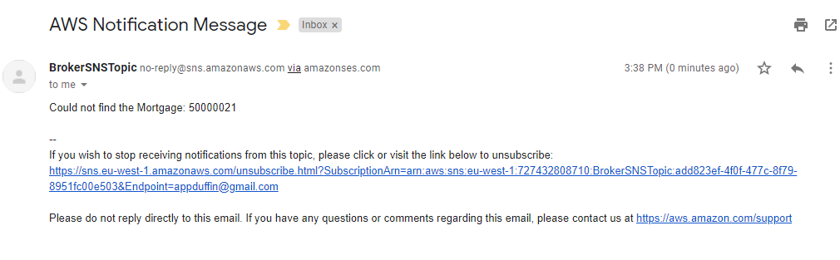
Figure AWS.STEP.TEST.2

I had to find a naming convention for potentially millions of concurrent workflow executions, so I use the NodeJS UUID module to assign execution names.
// Start the workflow
var params = {
"input": event.body,
"name": uuid(),
"stateMachineArn": workflowArn
}

The response from the HTTP /workflow/ POST Method is shown in Figure AWS.API.TEST.3
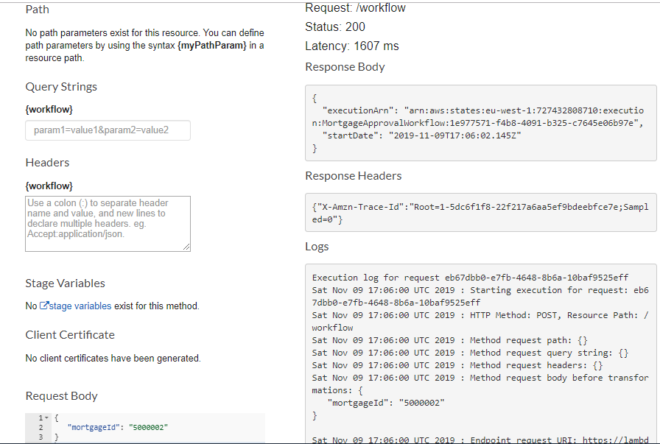
Figure AWS.API.TEST.3
A unique executionArn is returned. We can then query the Step Function API at a later stage to discover the output of the workflow execution.

The current implementation of the AutoAssessment Lambda function is fairly basic and only for demonstration purposes. It will reject an Auto Approval if the applicant has been in employment less than 10 years or is earning less than 100,000 euro. If an applicant does not meet these high criteria for Auto Approval then the next version of the workflow will route the application to a human Underwriter who can review the case and render a decision based upon other factors.

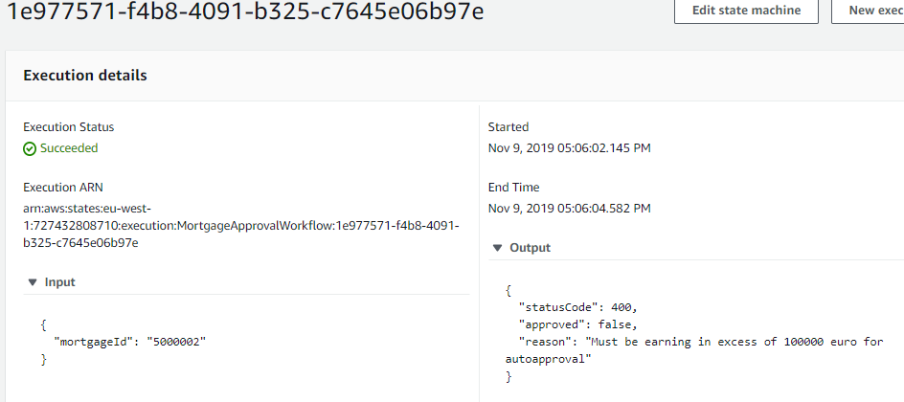
Figure AWS.API.TEST.4

However if the applicant satisfies all the criteria the mortgage application passes the Auto Assessment phase and does not need to be routed to a Human Underwriter for review.
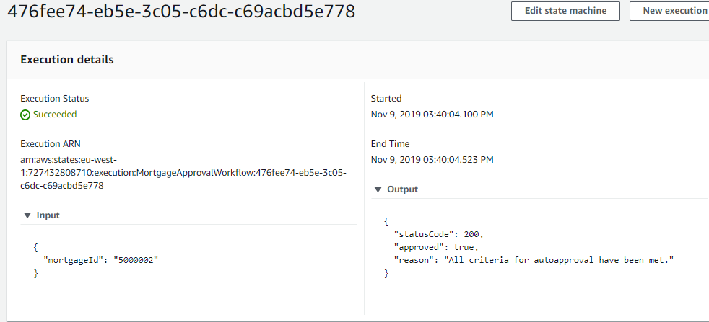
Figure AWS.API.TEST.5

Testing and Debugging the Workflow has not been trivial however the use of Cloudwatch logs has made the task easier. Tracing individual requests from the API Gateway to the Lambda layer, then to the Step Function execution and back to the Lambda execution can be quite tricky. AWS X-Ray is also very valuable.
For instance when seeing an empty response in the output section of the workflow, it can be time consuming to trace through the various layer. See Figure AWS.API.TEST.6

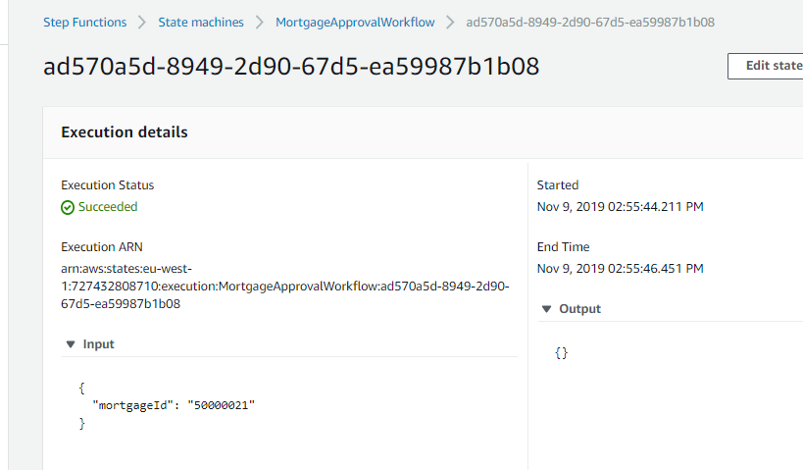
Figure AWS.API.TEST.6

Appendices

The following sections list some key / interesting source code / template snippets.

NodeJS Lambda – Start Step Function Execution

'use strict';

const AWS = require('aws-sdk'); // eslint-disable-line import/no-extraneous-dependencies
const uuid = require("uuid/v4");

const stepfunctions = new AWS.StepFunctions();

exports.handler = async (event, context) => {

try {
const workflowArn = process.env.MORTGAGE_WORKFLOW_ARN;

// Start the workflow
var params = {
"input": event.body,
"name": uuid(),
"stateMachineArn": workflowArn
}

const workflowExecution = await stepfunctions.startExecution(params).promise();
return {
statusCode: 200,
body: JSON.stringify(workflowExecution)
};
} catch (error) {
return {
statusCode: 400,
error: `Could not find the Mortgage: ${error.stack}`
};
}
};

NodeJS Lambda – Send SNS Topic Notification

'use strict';

const AWS = require('aws-sdk'); // eslint-disable-line import/no-extraneous-dependencies

// Create promise and SNS service object
const snsModule = new AWS.SNS({apiVersion: '2010-03-31'});

exports.handler = async (event, context) => {

let params = event;
try {
// Create promise and SNS service object
var data = await snsModule.publish(params).promise();
console.log(`Message ${params.Message} send sent to the topic ${params.TopicArn}`);
console.log("MessageID is " + data.MessageId);

return {
statusCode: 200,
messageId: data.MessageId
};
} catch (error) {
return {
statusCode: 400,
error: `Could not sent SNS notification [${params.Message}]`
};
}
};

NodeJS Lambda – Auto Assessment Function
'use strict';

const AWS = require('aws-sdk'); // eslint-disable-line import/no-extraneous-dependencies

const dynamoDb = new AWS.DynamoDB({apiVersion: '2012-08-10'});

exports.handler = async (event, context) => {

try {
const mortgageApplication = event;

if (mortgageApplication.yearsInEmployment != undefined && mortgageApplication.yearsInEmployment != null) {
let lengthOfService = toInt(mortgageApplication.yearsInEmployment)
if (10 > lengthOfService) {
return {
statusCode: 400,
approved: false,
reason: 'Must be employed for more that 10 years for autoapproval'
};
}
}
if (mortgageApplication.salary != undefined && mortgageApplication.salary != null) {
let salary = toInt(mortgageApplication.salary)
if (100000 > salary) {
return {
statusCode: 400,
approved: false,
reason: 'Must be earning in excess of 100000 euro for autoapproval'
};
}
}

return {
statusCode: 200,
approved: true,
reason: 'All criteria for autoapproval have been met.'
};
} catch (error) {
return {
statusCode: 400,
error: `Could run the Auto Assessment: ${error.stack}`
};
}
};

NodeJS Lambda – DynamoDB Update Mortgage

exports.updateMortgage = async function (mortgage) {

try {
var newMortgage = {
TableName: "MORTGAGES_TABLE",
Key: {
"mortgageId": {
S: mortgage.mortgageId
}
},
ExpressionAttributeNames: {
"#A": "loanAmount",
"#B": "yearsInEmployment",
"#C": "salary",
"#D": "employerName",
"#E": "term",
"#F": "mortgageStatus"
},
UpdateExpression: "set #A = :a, #B = :b, #C = :c, #D = :d, #E = :e, #F = :f",
ExpressionAttributeValues: {
":a": { "N": mortgage.loanAmount },
":b": { "N": mortgage.yearsInEmployment },
":c": { "N": mortgage.salary },
":d": { "S": mortgage.employerName },
":e": { "N": mortgage.term },
":f": { "S": mortgage.mortgageStatus }
},
ReturnValues: "ALL_NEW"
};

const updatedMortgageResponse = await dynamoDb.updateItem(newMortgage).promise();
const updatedMortgage = convertMortgageItemToHttpAPI(updatedMortgageResponse.Attributes);
return updatedMortgage;
} catch (error) {
console.log(error);
return null;
}
};

Servless Application Model – Cloudformation Template – Lambda / SNS / API Gateway
AWSTemplateFormatVersion: '2010-09-09'
Transform: AWS::Serverless-2016-10-31
Description: >
Tallaght-Mortgages-App

Globals:
Function:
Timeout: 3

Parameters:
LambdaRoleParameter:
Type: String
Default: "arn:aws:iam::727432808710:role/TUD.Mortgage.Lambda.Role"
Description: Enter the ARN of an applicable IAM Role for the Lambda Functions
StepFunctionArnParameter:
Type: String
Default: "arn:aws:states:eu-west-1:727432808710:stateMachine:MortgageApprovalWorkflow"
Description: Enter the ARN of the Workflow Step Function State Machine

Resources:

UnderwriterSNSTopic:
Type: AWS::SNS::Topic
Properties:
DisplayName: UnderwriterSNSTopic
Subscription:
- Endpoint: appduffin@gmail.com
Protocol: email
TopicName: UnderwriterSNSTopic
BrokerSNSTopic:
Type: AWS::SNS::Topic
Properties:
DisplayName: BrokerSNSTopic
Subscription:
- Endpoint: appduffin@gmail.com
Protocol: email
TopicName: BrokerSNSTopic

# CUSTOMER APIS
GetCustomerFunction:
Type: AWS::Serverless::Function
Properties:
CodeUri: customers/
Handler: get.get
Runtime: nodejs10.x
Role:
Ref: LambdaRoleParameter
Events:
GetCustomerEvent:
Type: Api
Properties:
Path: /customer/{id}
Method: GET
CreateCustomerFunction:
Type: AWS::Serverless::Function
Properties:
CodeUri: customers/
Handler: create.create
Runtime: nodejs10.x
Role:
Ref: LambdaRoleParameter
Events:
CreateCustomerEvent:
Type: Api
Properties:
Path: /customer/
Method: PUT
UpdateCustomerFunction:
Type: AWS::Serverless::Function
Properties:
CodeUri: customers/
Handler: update.update
Runtime: nodejs10.x
Role:
Ref: LambdaRoleParameter
Events:
UpdateCustomerEvent:
Type: Api
Properties:
Path: /customer/{id}
Method: POST

# MORTGAGE APIS
GetMortgageFunction:
Type: AWS::Serverless::Function
Properties:
CodeUri: mortgages/
Handler: get.get
Runtime: nodejs10.x
Role:
Ref: LambdaRoleParameter
Events:
GetMortgageEvent:
Type: Api
Properties:
Path: /mortgage/{id}
Method: GET
CreateMortgageFunction:
Type: AWS::Serverless::Function
Properties:
CodeUri: mortgages/
Handler: create.create
Runtime: nodejs10.x
Role:
Ref: LambdaRoleParameter
Events:
CreateMortgageEvent:
Type: Api
Properties:
Path: /mortgage/
Method: PUT
UpdateMortgageFunction:
Type: AWS::Serverless::Function
Properties:
CodeUri: mortgages/
Handler: update.update
Runtime: nodejs10.x
Role:
Ref: LambdaRoleParameter
Events:
CreateMortgageEvent:
Type: Api
Properties:
Path: /mortgage/{id}
Method: POST
DeleteMortgageFunction:
Type: AWS::Serverless::Function
Properties:
CodeUri: mortgages/
Handler: delete.delete
Runtime: nodejs10.x
Role:
Ref: LambdaRoleParameter
Events:
DeleteMortgageEvent:
Type: Api
Properties:
Path: /mortgage/{id}
Method: DELETE
ListByStatusMortgageFunction:
Type: AWS::Serverless::Function
Properties:
CodeUri: mortgages/
Handler: list.list
Runtime: nodejs10.x
Role:
Ref: LambdaRoleParameter
Events:
ListByStatusMortgageEvent:
Type: Api
Properties:
Path: /mortgage/
Method: GET

# WORKFLOW APIS
MortgageSNSFunction:
Type: AWS::Serverless::Function
Properties:
Handler: stepfunctions/notifications/mortgageStatus.handler
Runtime: nodejs10.x
Role:
Ref: LambdaRoleParameter
Environment:
Variables:
UNDERWRITER_TOPIC_ARN: !Ref UnderwriterSNSTopic
BROKER_TOPIC_ARN: !Ref BrokerSNSTopic
DependsOn:
- UnderwriterSNSTopic
- BrokerSNSTopic
NofifyUsersSNSFunction:
Type: AWS::Serverless::Function
Properties:
Handler: stepfunctions/notifications/snsNotifications.handler
Runtime: nodejs10.x
Role:
Ref: LambdaRoleParameter
Environment:
Variables:
UNDERWRITER_TOPIC_ARN: !Ref UnderwriterSNSTopic
BROKER_TOPIC_ARN: !Ref BrokerSNSTopic
DependsOn:
- UnderwriterSNSTopic
- BrokerSNSTopic

WorkflowGetCustomerFunction:
Type: AWS::Serverless::Function
Properties:
Handler: stepfunctions/customers/findByPK.handler
Runtime: nodejs10.x
Role:
Ref: LambdaRoleParameter
WorkflowGetMorgtageFunction:
Type: AWS::Serverless::Function
Properties:
Handler: stepfunctions/mortgages/findByPK.handler
Runtime: nodejs10.x
Role:
Ref: LambdaRoleParameter
WorkflowUpdateMorgtageFunction:
Type: AWS::Serverless::Function
Properties:
Handler: stepfunctions/mortgages/updateMortgage.handler
Runtime: nodejs10.x
Role:
Ref: LambdaRoleParameter
StartWorkflowFunction:
Type: AWS::Serverless::Function
Properties:
Handler: stepfunctions/startWorkflow.handler
Runtime: nodejs10.x
Role:
Ref: LambdaRoleParameter
Environment:
Variables:
MORTGAGE_WORKFLOW_ARN: !Ref StepFunctionArnParameter
Events:
StartWorkflowEvent:
Type: Api
Properties:
Path: /workflow/
Method: POST
AutoAssessmentFunction:
Type: AWS::Serverless::Function
Properties:
Handler: workflow/autoassessment.handler
Runtime: nodejs10.x
Role:
Ref: LambdaRoleParameter

Servless Application Model – Cloudformation Template – Step Function Workflow

{
"StartAt": "GetMortgageApplication",
"States": {

"GetMortgageApplication": {
"Type": "Task",
"Resource": "arn:aws:lambda:eu-west-1:727432808710:function:Mortgages-Stack-WorkflowGetMorgtageFunction-16L3UM67HNU4N",
"Next": "GetMortgageApplicationResult"
},

"GetMortgageApplicationResult": {
"Type": "Choice",
"Choices": [{
"Variable": "$.statusCode",
"NumericEquals": 200,
"Next": "AutoAssessment"
}],
"Default": "MortgageApplicationNotFound"
},

"MortgageApplicationNotFound": {
"Type": "Task",
"Resource": "arn:aws:lambda:eu-west-1:727432808710:function:Mortgages-Stack-NofifyUsersSNSFunction-216EXFJBHO0V",
"Parameters": {
"TopicArn": "arn:aws:sns:eu-west-1:727432808710:BrokerSNSTopic",
"Message.$": "$.error"
},
"End": true
},

"AutoAssessment": {
"Type": "Task",
"InputPath": "$.mortgage",
"Resource": "arn:aws:lambda:eu-west-1:727432808710:function:Mortgages-Stack-AutoAssessmentFunction-1FH398K5IHYU7",
"End": true
}
}
}

Reference List and Bibliography

[1] AWS Free Tier. https://aws.amazon.com/free/
[2] AWS CLI. https://docs.aws.amazon.com/cli/latest/userguide/install-windows.html
[3] AWS CLI SAM. https://docs.aws.amazon.com/serverless-application-model/latest/developerguide/serverless-sam-cli-install-windows.html
[4] Node JS. https://nodejs.org/en/download/
[5] Configure AWS CLI. https://docs.aws.amazon.com/cli/latest/userguide/cli-chap-configure.html
[6] Visual Studio Code. https://code.visualstudio.com/download
[7] Configure AWS on Visual Studio Code. https://docs.aws.amazon.com/toolkit-for-vscode/latest/userguide/setup-toolkit.html
[8] Install Docker Toolbox. https://docs.docker.com/toolbox/toolbox_install_windows/
[9] DynamoDB Cloudformation Template. https://github.com/GeneralYeager/tallaght.mortgages/blob/master/mortgage.dynamo/dynamo-create.yml
[10] Lambda Cloudformation Template. https://github.com/GeneralYeager/tallaght.mortgages/blob/master/tud.mortgages/Tallaght-Mortgages-App/template.yaml
[11] Step Function State Machine Template. https://github.com/GeneralYeager/tallaght.mortgages/blob/master/mortgage.workflow/StateMachineV1.json

